Ensemble Learning
What is Ensemble Learning?
Ensemble Learning is a machine learning technique where multiple models (weak or strong learners) are combined to produce a better, more robust model.
📌 Key Idea
“Many weak learners together form a strong learner.”

Why Ensemble Learning?
Single models often suffer from:
- High variance → overfitting
- High bias → underfitting
- Sensitivity to noise
Ensembles help by:
- Reducing variance
- Reducing bias
- Improving generalization
- Increasing stability

Types of Ensemble Learning
- Bagging (Bootstrap Aggregating)
- Boosting
- Random Forest
- Stacking (Stacked Generalization)
- Blending
- Voting Ensemble (Hard Voting / Soft Voting)
- Averaging Ensemble (for Regression)

1️⃣ Bagging (Bootstrap Aggregating)
What is Bagging?
Bagging trains multiple models independently on different bootstrap samples (random sampling with replacement) and then aggregates their predictions.

🔁 How Bagging Works (Step-by-Step)
- Given dataset D
- Create N bootstrap samples (same size as D)
- Train N independent models on each sample
- Combine predictions:
  - Classification → Majority vote
  - Regression → Average

✅ Example
- Algorithm: Decision Tree
- Models: 100 trees
- Each tree sees different data
- Final prediction = majority vote

🎯 Why Bagging Works
- Reduces variance
- Prevents overfitting
- Works best with high-variance models

⚠️ Limitations
- Does not reduce bias
- Computationally expensive

📌 Popular Bagging Algorithm
✔ Random Forest (advanced form of bagging)

2️⃣ Boosting
What is Boosting?
Boosting builds models sequentially, where each new model focuses on correcting errors made by previous models.

🔁 How Boosting Works
- Start with equal weights for all data points
- Train first weak learner
- Increase weight of misclassified samples
- Train next learner focusing on difficult samples
- Combine all models using weighted voting

🔥 Key Boosting Algorithms
Algorithm | Key Idea
AdaBoost | Misclassified points get higher weight
Gradient Boosting | Learns from residual errors
XGBoost | Optimized gradient boosting
LightGBM | Faster, leaf-wise growth
CatBoost | Handles categorical data well

🎯 Why Boosting Works
- Converts weak learners into strong learner
- Reduces bias
- Handles complex patterns

⚠️ Limitations
- Sensitive to noise and outliers
- Overfitting if too many iterations

3️⃣ Random Forest (Most Important ⭐)
What is Random Forest?
Random Forest is an ensemble of decision trees built using:
- Bagging (bootstrap sampling)
- Random feature selection
This makes trees less correlated and more accurate.

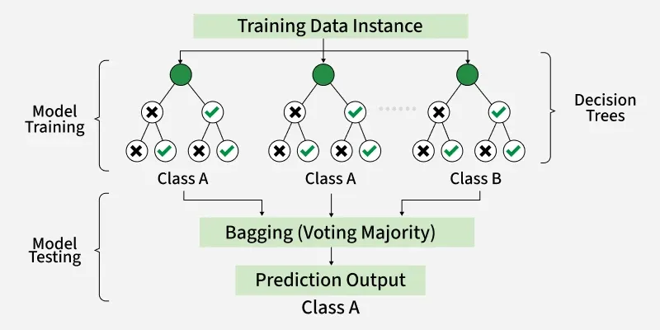
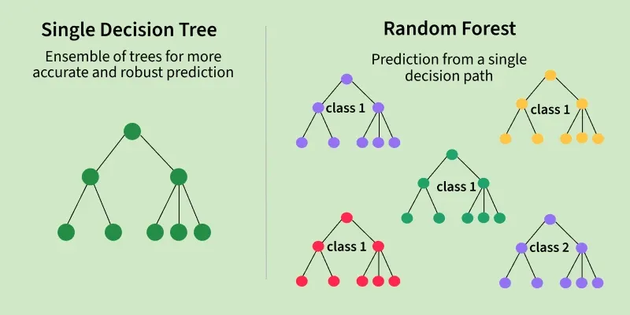
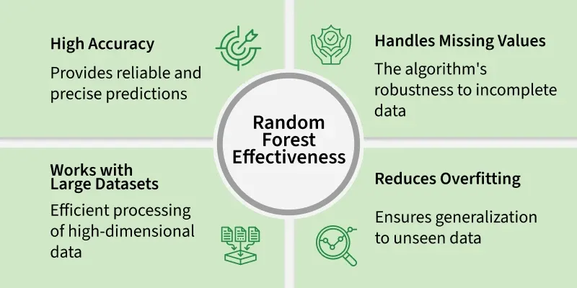

🧠 Key Innovations in Random Forest
- Bootstrap sampling of data
- Random subset of features at each split
- Decision trees grow independently
- Final prediction via aggregation

🔁 Random Forest Algorithm (Step-by-Step)
- Choose number of trees N
- For each tree:
  - Sample data with replacement
  - At each node:
    - Randomly select m features
    - Choose best split using Gini / Entropy
- Grow trees fully (no pruning)
- Aggregate predictions

🌳 Random Forest Flow Chart (Algorithm)
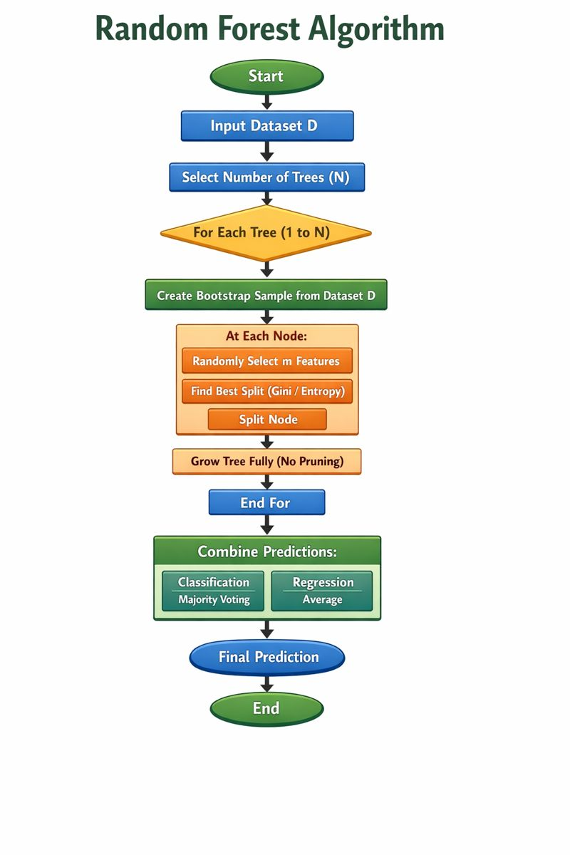

🎯 Why Random Forest Works So Well
- Reduces overfitting
- Handles non-linearity
- Robust to noise
- Works well with high-dimensional data

📊 Bagging vs Boosting vs Random Forest
Feature | Bagging | Boosting | Random Forest
Training | Parallel | Sequential | Parallel
Focus | Variance | Bias + Variance | Variance
Sampling | Bootstrap | Weighted samples | Bootstrap
Feature randomness | ❌ | ❌ | ✅
Overfitting control | Medium | Low | High
Noise sensitivity | Low | High | Low

4️⃣ Stacking (Stacked Generalization)
📌 Definition
Stacking combines different types of models and uses a meta-model to learn how to best combine them.

⚙️ How it works
- Train base models (e.g., SVM, RF, KNN)
- Collect their predictions
- Use predictions as input for meta-model
- Meta-model makes final prediction

🎯 Purpose
✔ Learn optimal combination of models

🔧 Example
- Base models: Decision Tree, SVM, KNN
- Meta-model: Logistic Regression

5️⃣ Blending
📌 Definition
Blending is similar to stacking but uses a hold-out validation set instead of cross-validation.

⚙️ How it works
- Split data into:
  - Training set
  - Validation set
- Train base models on training data
- Train meta-model on validation predictions

🎯 Purpose
✔ Simpler alternative to stacking

⚠️ Limitation
- Less data for training

6️⃣ Voting Ensemble
📌 Definition
Voting combines predictions from multiple different models using voting.

Types of Voting
Type | Description
Hard Voting | Majority class
Soft Voting | Average probabilities

🎯 Purpose
✔ Improve accuracy using diverse models

🔧 Example
- Logistic Regression + SVM + KNN

7️⃣ Averaging Ensemble (Regression)
📌 Definition
Used mainly for regression by averaging predictions of multiple models.

🎯 Purpose
✔ Reduce prediction variance

🔥 Summary Table
Type | Training Style | Reduces | Example
Bagging | Parallel | Variance | Random Forest
Boosting | Sequential | Bias | XGBoost
Random Forest | Parallel | Variance | RF Classifier
Stacking | Meta-learning | Both | Stacked Model
Blending | Hold-out | Both | Simple Stack
Voting | Parallel | Variance | Hard/Soft Voting
Averaging | Parallel | Variance | Regression Ensemble

